Resources for Adolescents During Remote Learning

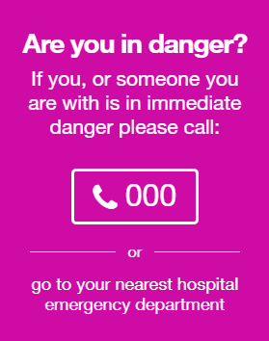

If you need to talk to someone…

Name | About | Phone | Online
Kids Help Line | For anyone 25 or under - Kids Helpline is a free, private and confidential 24/7 phone and online counselling service for young people aged 5 to 25. | 1800 55 1800  24/7 | Webchat 24/7  https://kidshelpline.com.au/get-help/webchat-counselling
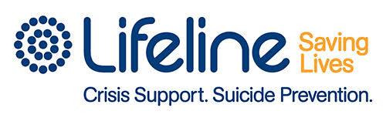  Lifeline | For all ages - 24-hour crisis support telephone service. Lifeline provides 24/7 crisis support and suicide prevention services. | CALL: 13 11 14  24/7  TEXT: 0477 131114  6:00PM - Midnight | Crisis Support Chat 7:00PM – Midnight  https://www.lifeline.org.au/get-help/online-services/crisis-chat
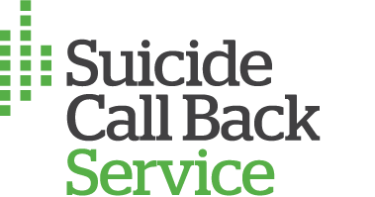  Suicide Call Back Service | A nationwide service that provides 24/7 telephone and online counselling to people who are affected by suicide, experiencing thoughts of self-harm or suicide | 1300 659 467  24/7 | Online Chat 24/7  Video Chat 24/7  https://www.suicidecallbackservice.org.au/
Youth Beyond Blue | Beyond Blue provides information and support to help everyone in Australia achieve their best possible mental health, whatever their age and wherever they live. | 1300 22 4636  24/7 | Chat Online  3:00PM - Midnight  https://www.youthbeyondblue.com/
SANE Australia | SANE Australia supports people living with complex mental health issues and the people that care about them | 1800 187 263  10:00AM – 10:00PM | Webchat  10:00 AM – 10:00 PM  https://www.sane.org/about-sane
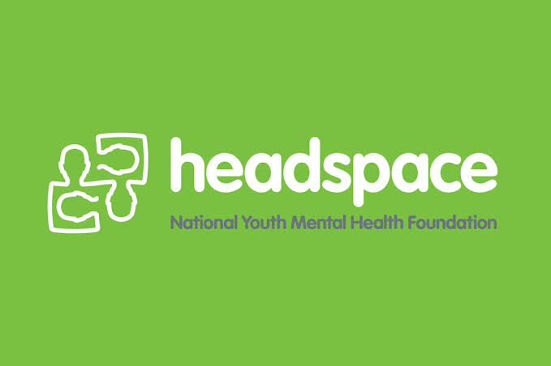  Headspace | eheadspace provides free online and telephone support and counselling to young people 12 - 25 and their families and friends. | N/A | Group Chat 24/7  1 on 1 Chat  9AM - 1AM https://headspace.org.au/eheadspace/
QLife | QLife provides anonymous and free LGBTI peer support and referral for people wanting to talking about sexuality, identity, gender, bodies, feelings or relationships | 1800 184 527  3PM - Midnight | Webchat  3PM – Midnight  https://www.qlife.org.au/resources/chat
1800RESPECT | Confidential information, counselling and support service, open 24 hours to support people impacted by sexual assault, domestic or family violence and abuse | 1800 737 732  24/7  Interpreter: 13 14 50 | Online Chat 24/7  https://chat.1800respect.org.au/#/welcome
Carers NSW | Carer Line offer emotional support, referrals and distribute carer specific resources and information to carers and community members | 1800 242 636  9AM – 5PM  Monday - Friday | http://www.carersnsw.org.au/how-we-help/support/carer-line/
Mental Health Line | ​ A mental health professional will answer your call about mental health concerns for you or someone you are concerned about, including children, teens, adults and older people | 1800 011 511  24/7 | https://www.health.nsw.gov.au/mentalhealth/Pages/Mental-Health-Line.aspx
 | Child Protection Helpline | 13 21 11 | https://reporter.childstory.nsw.gov.au/s/mrg
If you are looking for an app…

Name | About | Website
Calm Harm | Calm Harm provides tasks that help you resist or manage the urge to self-harm. You can add your own tasks too and it's completely private and password protected. | Free  App Store  Google Play
Clear Fear | The fear of threat, or anxiety, is like a strong gust of wind. It drags you in and makes you want to fight it or run away.  Instead, face your fear with the free Clear Fear app and learn to reduce the physical responses to threat as well as changing thoughts and behaviours and releasing emotions. | Free  App Store  Google Play
ReachOut Worry Time | ReachOut WorryTime interrupts repetitive thinking by setting aside your worries until later, so you don't get caught up in them and can get on with your day. This means you can deal with worries once a day, rather than carrying them around with you 24/7 | Free  App Store
ReachOut Breathe | ReachOut Breathe helps you reduce the physical symptoms of stress and anxiety by slowing down your breathing and your heart rate with your iPhone | Free  App Store
Smiling Mind | Smiling Mind is a meditation app for young people. It has been developed by a team of psychologists and uses mindfulness to boost calmness, contentment and clarity. Mindfulness meditation has been shown to help manage stress, resilience, anxiety, depression and improve general health and wellbeing. | Free  App Store  Google Play
WellMind | WellMind is designed to help you with stress, anxiety and depression. The app includes advice, tips and tools to improve your mental health and boost your wellbeing. | Free  App Store  Google Play

If you are looking for online support…

Name | About | Website
Bite Back | Promoting resilience and wellbeing in 12-18-year old’s through activities | https://www.biteback.org.au/
The BRAVE Program | BRAVE-ONLINE is an evidence-based cognitive behavioural therapy (CBT) available online to help children (8-12) and teenagers (13-17) cope with anxiety | https://www.brave-online.com/
ConnectEDSpace | A website provided by Relationships Australia Victoria with tip sheets, news and useful links to help young people manage problems and issues such as bullying, relationships, stress and mental health, and conflict with parents | https://www.connectedspace.com.au/
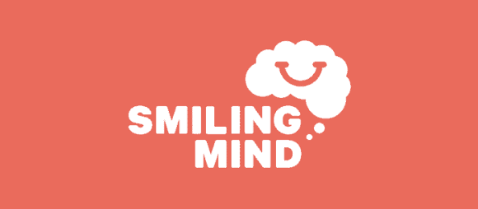  Smiling Mind | Online and app-based program to improve wellbeing of young people through mindfulness meditation. | https://www.smilingmind.com.au/
MyCompass | Are you feeling the pressures of study, finding a job or starting a career? It has an interactive self-help service that aims to promote resilience and wellbeing for people experiencing mild to moderate stress, anxiety and/or depression | https://www.mycompass.org.au/YoungAdults

If you are seeking additional information…

Name | About | Website
ReachOut | Our mission is to deliver innovative e-mental health services that enable young people to take control of their mental health and wellbeing. | https://au.reachout.com/
Black Dog Institute | Primary areas of mental health research and treatment include: depression, bipolar disorder, post-traumatic stress disorder (PTSD), anxiety, workplace mental health, adolescents and young people, suicide prevention, e-mental health, and positive psychology and wellbeing. | https://www.blackdoginstitute.org.au/

