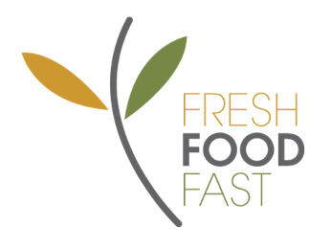

Choice of Cheese, Egg Mayo, Tuna Mayo, Ham or Chicken, all served with Tomato, Cucumber, Lettuce and Grated Carrot

Chicken Caesar Wrap 5.00

(Chicken, Cheese, Lettuce and Caesar Dressing)

Big Crunch Sushi Hand Roll 4.00

(Teriyaki Chicken / Tuna / Vegetarian)

Garden Salad 5.00

Add on Tuna / Feta / Chicken / Egg 1.00

Fruit Salad Pot 3.00

Yoghurt, Strawberry Coulis and Granola Pots 3.00  
Banana Bread 2.50

Ham and Cheese Toasted Wraps 2.50

Bagel with Butter, Jam or Vegemite 2.50

Homemade Cheese and Ham Muffins 2.00  
Cheese and Bacon Roll 2.00

Cheese and Vegemite Scrolls 2.00

Toast with Butter, Jam or Vegemite 1.50

Watermelon Slice 1.00

Apple 1.00

Snacks

Red Rock Chips (Sea Salt) 2.00

Ham & Cheese Toasted Wraps 2.00

Homemade Cheese and Ham Muffins 2.00

Popcorn 1.00

Anzac Biscuit 1.00

Chicken Tenders x 3 with Sauce Pot 5.00

Minced Beef Pie 5.00

Meat and Mashed Potato Pie 5.00

Sausage Rolls 4.00

Potato Wedges with Sauce 2.50

Garlic Bread 2.50

Corn on the Cob 2.50

Every Day Hot Food

Single Wrap 3.00

Double Wrap 5.00

Orchy Orange Juice 200ml 3.50

Orchy Apple Juice 200ml 3.50

Orchy Orange and Passionfruit Juice 200ml 3.50

Orchy Apple and Blackcurrant Juice 200ml 3.50

Norco Chocolate / Strawberry Milk 500ml 4.50

Norco Chocolate / Strawberry Milk 300ml 3.00

Waterfords (Orange Passionfruit, Blackcurrant, Raspberry) 3.50

Water 600ml 1.50

Open Monday, Wednesday, Thursday and Friday from 8.30am - 2.10pm

Tuesday 8.30am - 1.10pm

Twisted Frozen Yogurt 3.00

(Strawberry, Chocolate or Mango/Watermelon)

Moosies (Chocolate/Bubblegum) 2.00

Quelch Fruit Sticks 1.00

Frozen Items

Drinks

Everyday Cold Food

Breakfast

HENRY KENDALL HIGH SCHOOL CANTEEN

Term 4 2019