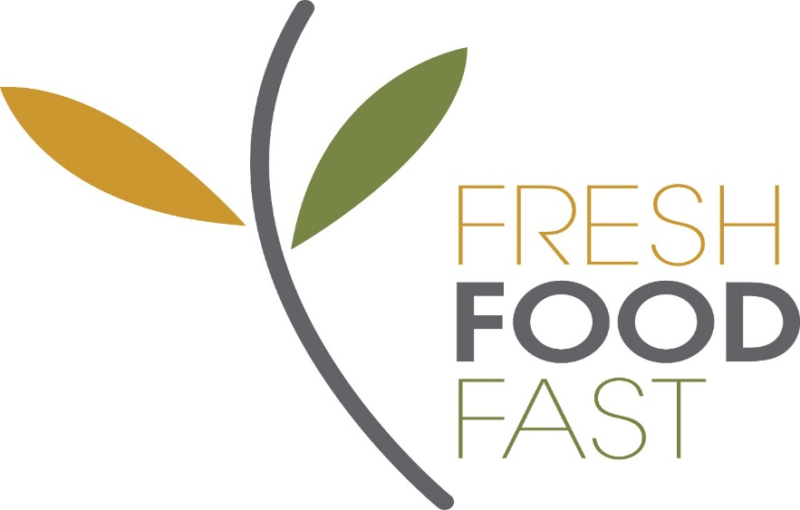
www.freshfoodfast.net.au
Opening Hours
Henry Kendall High School Canteen is open 5 days a week.
Before school 8.30am - 8.55am
Recess 11.10am - 11.40am
Mon – Fri Lunch 1.40pm - 2.10pm (Tues 12.40pm – 1.10pm)
Operated by Fresh Food Fast catering and run by owner Jackie Stansfield.
Payment
We operate Flexischools, an online lunch and recess ordering system. For details on how to register and how the system works go to www.flexischools.com.au
Payment can also be made with cash, no cheques are accepted
Volunteers
Always looking for parent volunteers, please contact Jackie on 0488123931 if you are able to help. Even 15 minutes once a term would be greatly appreciated! Each month, all volunteer names go into a draw for a free evening meal for four people, and your child receives a free lunch order for every two hours volunteered. We have a facebook page you can request to join, 'Henry Kendall Public School Canteen Volunteers'.
Breakfast Menu
Cheese and bacon rolls, ham and cheese toasted wraps and fruit pots.
Tea, coffee and hot chocolate is available for $2.50 from 8.30am to 2.00pm
Recess Menu
Please see the menu attached below for the daily specials
$2.00 each
Lunch Menu
Please see the hot daily special on the menu attached below for the daily specials.
All $5.00 each.
Range of burgers, hot wraps and subs, and nachos are available daily along with a range of boxed salads, sushi and sandwiches.
Special dietary requirements
If your child has special dietary requirements such as gluten free and you would still like to use the canteen on a regular basis, please contact Jackie on 0488123931 to discuss the options available, as we are happy to make products. Please note there will be slight increase in the price due to the cost of the gluten free ingredients.
Evening Meal Service
Time short? Over cooking at the end of a long day? Fussy eaters? If you are wanting to still provide a homemade healthy meal each evening, the Canteen is now offering an evening meal service. $9.00 per meal or 4 for $32. Freshly prepared on the day and pre packaged in a microwavable container, which is also suitable for home freezing. Collection can be made from the Canteen . Any special dietary requirements, please speak to the canteen as we can adapt the recipes where necessary. You can order on Flexischools, under the Evening Meal Catalogue.
Please like the fresh food fast Facebook page to be updated on all canteen menus, special offers and updates:

https://www.facebook.com/Fresh-Food-Fast-337683416416591/

