Port Stephens Excursion

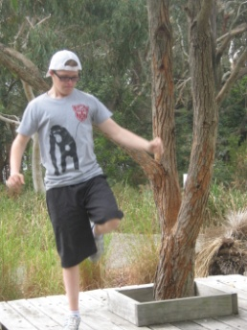
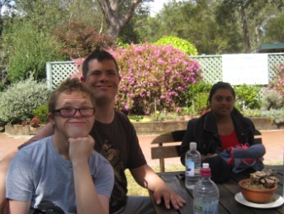
On Monday 9 September Mitchell, Matthew and Sonalie set off with Mrs. Bennett and Mrs Tulloch on a trip to Port Stephens. It was a beautiful sunny day and we travelled in Mrs Tulloch’s car. Our first stop was for morning tea at Hunter Botanic Gardens. The flowers were beautiful. We walked around a pathway and saw some amazing cactus plants and some animal foot prints on stepping stones.

We travelled on to Tanilba Bay and visited the Tilligerry Wildlife Reserve. We were hoping to spot some koalas in the wild. The day was warming up and we had to look out for snakes. Mitchell guided us with the map and during the bush walk Matthew tried out all the seats along the way. We heard some grunting but were unable to see any koalas (except the one Sonalie saw in the Visitors’ Centre). After a picnic lunch Mitchell did a rap dance. We think the koalas may have been keeping cool and watching us!

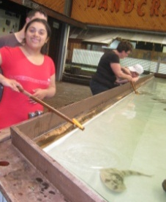
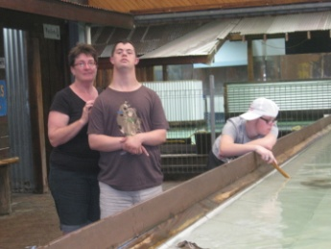
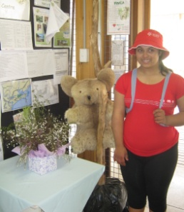
We travelled to Nelson Bay where we all helped to do the shopping. It was great to arrive at Fingal Bay and relax in our comfortable cabin. Matthew played pickup sticks, Mitchell did colouring and Sonalie wrote some letters. Mrs. Tulloch made pasta, meatballs and vegetables for dinner. Sonalie was keen to watch the X Factor on TV that evening. After a big day, it was good to be off to bed. We all slept well.
We spent the afternoon at the Shark and Ray Centre where we fed and saw some amazing creatures.
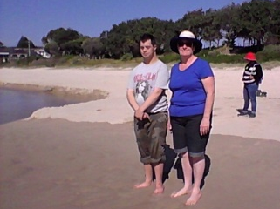
On Tuesday morning we woke to another bright, sunny day. After breakfast we walked across to Fingal Bay Beach. Too soon it was time to brush off the sand and pack our things ready to go.
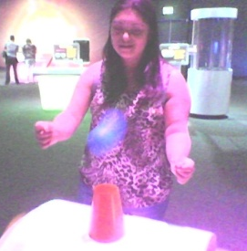
We had a quick morning tea stop at Little Beach but the wind was so strong even the pelicans were struggling to fly. We continued our journey to Newcastle regional Museum. There we did some fantastic hands on science activities. Sonalie balanced some balls on a stream of air. Matthew lifted a car using ropes and levers. Mitchell made a mini tornado. We also saw a special sound, smoke and light presentation of a steel smelter at work which was very exciting. After lunch on the grassy knoll it was time to head back to school. (There were sounds of snoring to be heard from the back seat on the way home).

