Kokoda Youth Leadership Challenge 2013
We wish Reece Jones well these coming school holidays as he takes on the challenge of walking the Kokoda Track. Reece is one of two local students sponsored by Gosford RSL for the Kokoda Youth Leadership Challenge of 2013. This leadership program aims to create a greater awareness of the sacrifices of the diggers on the Kokoda campaign among our young people to ensure the traditions live on. At the same time it instils in participants a commitment to community service, enhance their personal development by providing an opportunity for them to experience the same conditions under which our diggers fought and hopefully transform them for future leadership roles back in the community.
One of the places he will be visiting is the Bomana Commonwealth War Grave Cemetery. Located near Port Morsbey this cemetery is the final resting place for 3779. “There are 3069 known and 237 unknown Australians from the fighting in New Guniea together with 443 allied soldiers, sailors and airmen”. For more details see http://kokoda.commemoration.gov.au/about-the-kokoda-track/bomana-cemetery.php
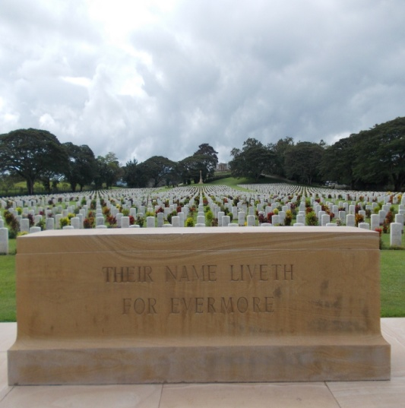
Bomana – 2 June 2012
Isurava will also be a memorable experience for Reece and his fellow trackers. Arguably one of the most impressive memorial sites along the Kokoda Track. Isurava stands as a testament to the four pillars – Courage, Endurance Mateship and Sacrifice.

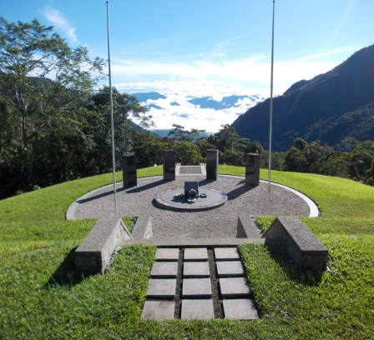
Isurava Memorial 12 June 2012
If you are interested in learning more about the Kokoda campaign there are two internet sites that provide an excellent insight to the nature of a conflict that Australia and Japan share as a part of their common history.
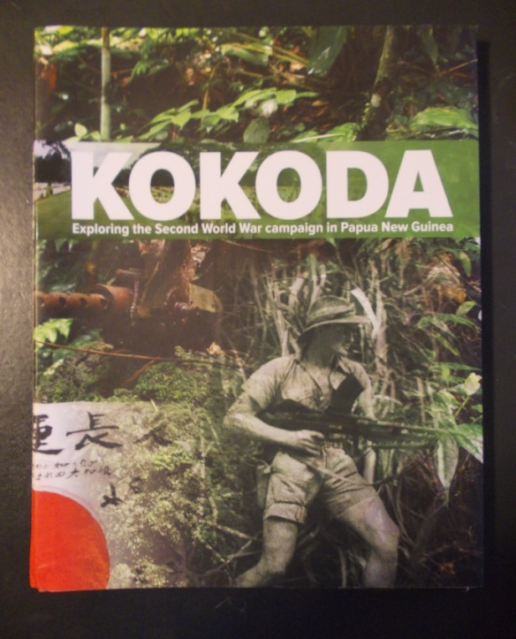  Department of Veterans’ Affairs 2012, Kokoda: Exploring the Second World War campaign in Papua New Guinea, DVA Education Resource. Published March 2012  This exceptional educational resource provides substantial teaching and learning resources for the study of the Kokoda campaign.  See website at  www.kokoda.commemeration.gov.au | Published on Feb 3, 2013  “Beyond Kokoda is a documentary series screened on the History Channel giving a soldier's perspective of the Kokoda Campaign. With interviews from Australian and Japanese veterans, the documentary gives a shared experience of war and moves away from the cliches surrounding the campaign. Episode 1 is from an Australian perspective while Episode 2 is from the Japanese perspective. This segment wraps up the documentary series by exploring what the veterans did after the war, their thoughts and recollections of the Kokoda Campaign and their lost comrades.” YouTube  http://www.youtube.com/watch?v=z4FBktblMFM

Lest we forget.

