Max Potential - http://max-potential.com.au

The Max Potential project offers 22 weeks of personal leadership development, including coaching, to young leaders from schools, and the community, to help them maximise their potential during the final years at school, and beyond. It also encourages students to focus on the local community and ways that they can work to improve it.

On Thursday 8 August three HKHS students celebrated the achievement of completing this program at Gosford RSL. Below is an outline of each student’s activities and we offer each of them our congratulations.

Current Year 10 students will be given to apply for this program later in the term.
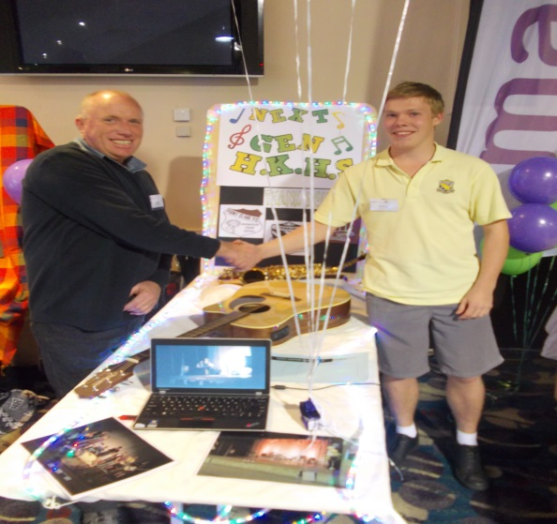
Matt and his coach Kevin

Matt Callaghan - Max Potential for me was really a surprise and talking to Suzy, the organizer, made me think that it could help me. Next thing you know I’m at an introduction meeting learning how to plan better and work from the root to get the rewards, which was helping resolve my organisational problems.

For my Community Service Project I had it all planned out. I was going to do a musical performance for the senior people at a retirement village. I had a date and all I needed to do was get the performers, but sadly the village pulled out because of the change of new management. I tried other places but it couldn’t happen. I was pretty down. But my coach Kevin helped and learning from the program I got back up and faced the failure. I asked for advice from my teachers and my music teacher said that I could organise a performance for a celebration ceremony. So here I am now writing this article to you. This shows that this program has helped me to solve problems, get back up and face the failure.
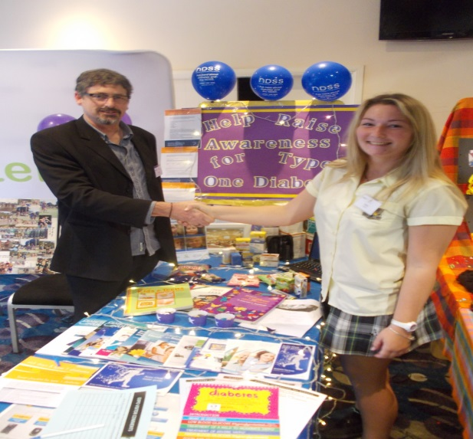
Emily and her coach David

Emily Wardle - When I first discovered my name had been put forward by my school to apply for this Max Potential Program, I honestly had never heard of it before. When I took the application forms I was a bit apprehensive. The program sounded amazing and all the benefits you receive later on down the track from doing the program were extremely inviting. The main concern I had with joining up to the program would be time management, with being in year 11, I was worried about the increased work load so I decided to apply and see how I went.

With so many strong applicants with amazing portfolios I didn’t think I would be considered, but I was selected and it has been one of the most amazing and rewarding experiences I have ever been involved with. It has been extremely beneficial to my life and has shown me where I can improve and how to get to where I want to go in the future.
The program isn’t just about you either, you get the opportunity to give back to the community and helps justify how to turn yourself into a better person by assisting the community. It can be as big as or as little as you make it out to be but no matter what you do, you will help someone in someway.

The bond you create between you and your coach is truly one of the most rewarding things you get out of the whole program. The chance to work one on one with someone who has heaps of experience in these areas and having being paired up together because of your interests, is truly worthwhile. You become such good friends and experience so much together.

It is seriously such a good program and I recommend it highly to anyone. You don’t have to be the smartest in the year or the best at sport, anyone can get into this program and benefit from it.
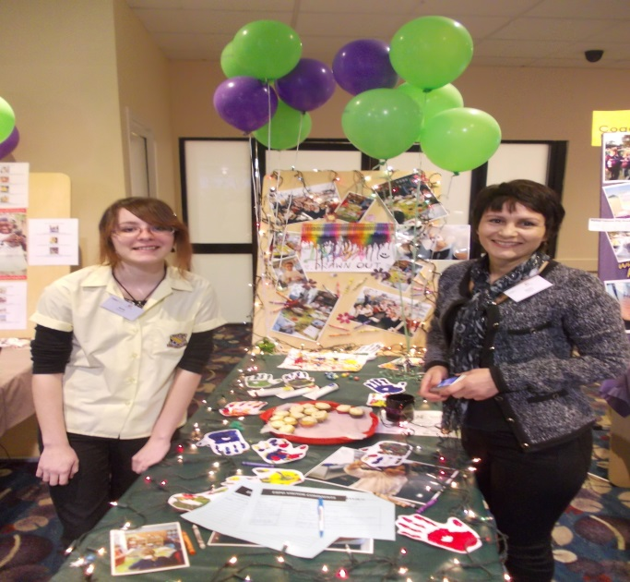
Amie and her coach Daria

Amie Shultz - For my community service project I am working with my friend Emma to demonstrate creative activities with a group of primary school children through an art workshop and our project is called "Drawn Out". The reason why I chose this as my project is because creative expression is something that tends to be overlooked or under-appreciated in schools these days, and equally something that I love to do. We plan to use a simple but entertaining approach. ie. making puppets and hand and finger painting. By the end of it I hope that we will not only have given the children a fun and interesting activity that they can show their parents, but also given them a chance to discover something new they might enjoy.
Max Potential has been a great opportunity for me because it has not only provoked me to think about aspects of my life in a different way but also how to approach them and work towards being the person that I want to be. I have always been one of the shyest people you will ever meet, but working with the Maximisers has taught me how to deal with conflicts that I come across - X out the negatives - and how to get my ideas across confidently and learn to communicate better - Make things happen. Through this, and working with my coach Daria Florea, I feel that I have grown and become a better person - something I didn't think I could do before. :)

